The Steering Wheel

**May, 2020**

Newsletter of the Midwest Antique Auto Club

Not affiliated with any national club.

An independent group of collectible vehicle enthusiasts.

Dedicated to the preservation of the antique/collectible automobile.

Presidents John & Karen Thurber Ph. (402)-496-7701

Vice Presidents Dave Hansen Ph. (402)-350-6505

Secretaries Gloria & Tom Kannas Ph. (712)-566-9818

Treasurers Dixie & Ken Foote Ph. (712)-566-2803

Tour Committees Ed & Janet Hedegaard Ph. (712)-566-2220

Tour Committees Jim & Cheryl Cushman Ph. (402)-558-0150

News Letter Editors **We still need someone** Ph. (xxx)-xxx-xxxx

### Historians Clif & Joyce Ellis Ph. (402)-397-4279

Meetings are held on the third Sunday of each month. The Board meets at 1:30 p.m. and the general meeting begins at 2:00 p.m. during the months of November, January, February and March at the **NEW CASSEL RETIREMENT CENTER at 900 N. 90th St., Omaha, NE 68114.** During the summer months of April, May, June, July, August, September and October, there are no inside meetings. In these months we have “Official Car Tours” on the third Sunday of each month. Plus whatever extra tours may please us. There is no meeting in December, that meeting is replaced by our annual Christmas banquet. All vehicles are welcome, any year, make or model, but a drivable collectible/antique vehicle is not a requirement for membership.

The deadline for articles for the Steering Wheel is the last Saturday of the month.

#### The President’s Message

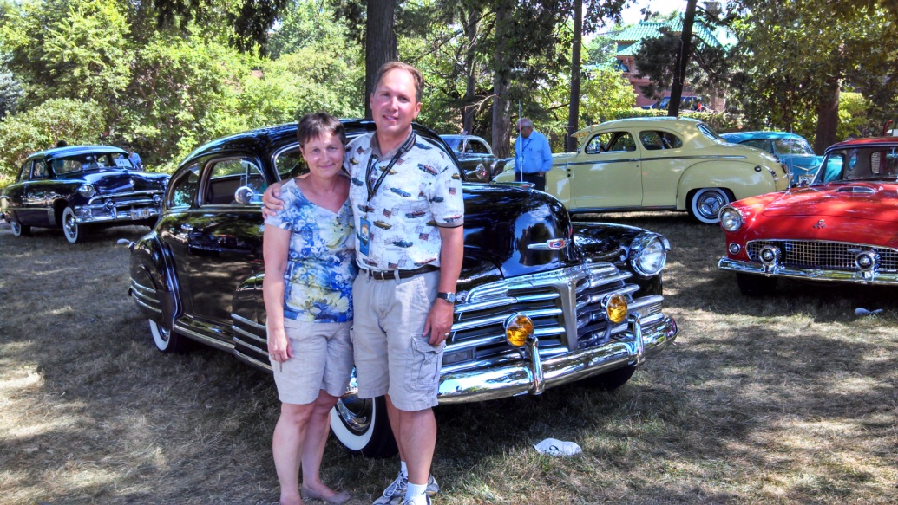Hello Everyone,

I hope you are staying safe and healthy while we stay at home due to the COVID-19 pandemic. I know that it has been tough on a lot of people with most businesses closed for walk-in customers. Karen and I have been working from home since mid-March. We have tried to help local restaurants with take-home orders but I know that most small businesses have been hurting. If you need any help with grocery store purchases, please let me or Karen know. We would be happy to help.

We are going to try a socially distant driving tour in May for all of those that are comfortable to meet in our cars and drive. There is no obligation to participate. We just want to get out and drive our cars and not have any food or outside meeting. Please be safe and we hope to see you soon.

John and Karen Thurber☸

**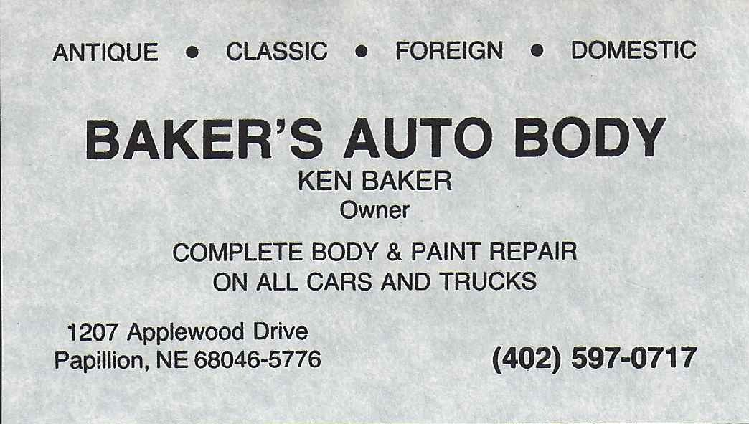CALENDAR OF EVENTS**

**May 17th (Sunday)**

We are planning a socially distant driving tour where we stay in our cars and drive around Council Bluffs, Crescent and North Omaha. **We are not planning on meeting as a group or having any food.** Our plan is to meet at 1:00 p.m. at the Bomgaars on 2303 E. Kanesville Blvd, Council Bluffs. We will be leaving at 1:30 and visiting the Lincoln and Lewis & Clark Memorials in Council Bluffs, driving to Crescent Iowa and ending our tour at the Zestos on North 30th Street in North Omaha for those that want to purchase ice cream. Please join us if you feel comfortable doing so.

**June 20th (Saturday)**

We are still planning to have a car show at New Cassel Retirement Center (900 N. 90th Street, Omaha) from 11:00 a.m. to 2:00 p.m. We are currently discussing the car show with the management of the facility. We will make sure that we are safe with either showing our cars or driving our cars past the front door of the facility. We will let you know more about this event in next month’s newsletter.

June 17th-20th, 2020

The Tour to Norfolk with the Omaha Region Horseless Carriage Club has been cancelled due to the COVID-19 pandemic.

**Member News**

**\*\*DUES ARE PAST DUE! PLEASE SEND THEM TO DIXIE FOOTE IF YOU HAVE NOT YET PAID.**

We were sorry to hear that former member Richard (Dick) Sorensen has passed away on April 9th. Please keep Connie and the rest of Dick’s family in your thoughts and prayers.

Hemmings Motor News Article

**Mike Dennis to retire after 40-plus years of selling Ford parts**

By Jim O'Clair

Anyone who has read the Ford Parts for Sale classified ads in the last 30 years or has undertaken a pre-1960s Ford restoration will know who Mike Dennis is. As the owner of **Nebraska Ford Parts**, Mike has been fulfilling parts orders and pounding the pavement looking for cherry NOS and premium-quality used items for all those years, and then some. Each month, his list of available Ford parts contains many hard-to-find restoration items for 1930s through 1950s passenger cars and trucks, including rust-free sheetmetal, trim, interior pieces, and accessories. That inventory of parts does not come easily, as we learned when we dragged him away from his telephone order desk for a few minutes to catch up with him.Hemmings

Daily: Mike, how did you get started in the classic Ford parts business?

Mike Dennis: As a kid, even in high school, I was always interested in early Ford V-8s. My father was a car builder and restorer who would often buy several donor cars to make into one complete car. After the project was complete, we would travel to area swap meets to sell off the pieces we did not use. As the sales of these items became more popular and profitable than the restoration work, I shifted to exclusively providing parts to other restorers, learning along the way what my customers needed the most and endeavoring to find those items for them. Eventually, the business turned into a traveling road show where my wife, Martha, and my son and daughter would travel with me in our motor home towing a box trailer behind. We attended swap meets, V-8 Ford events, and auctions, often over extended weekends. The kids have been coming along since they were in preschool, and they and Martha would package up our new acquisitions and I would do most of the finding and purchasing. As the kids grew, they got to come along if they kept their grades up, so it was an incentive for them to do well in school also.

HD: Typically, how far would you travel to find these items?

MD: We have been all over the Midwest and as far north as Winnipeg to attend Ford meets and auctions. We also occasionally travel to the East Coast, to big Ford events at Hershey and Carlisle. One of our favorites was the Pate Swap Meet in Cresson, Texas, which moved to Texas Motor Speedway in 1998.

HD: Although we are sure all your customers have been important to you over your long career, are there any celebrities or recognizable names who have done business with you that you can remember?

MD: Most of our customers have been doing business with us for many years. Word of mouth, and our ads in Hemmings Motor News, have established many friendships and business relationships with great customers. I guess there have been at least 20,000 customers over the years. While I can’t recall any people of renown off the top of my head, I know that we did quite a lot of business with Disneyland in years past. They maintain a rather large fleet of classic Fords, although not as many as they did when we first got started in the business.

HD: Is there one rare or unique Ford part you were able to acquire that stands out in your memory?

MD: Not really. There have been a lot of items I have actively looked for that I have yet to find, but most of these were unique to one model or year. Although I have found many of these items, the truth is that the owners knew what they had and were not willing to let them go or wanted too much money for me to make a profit selling them. In these cases, I simply forward the information to my customer and have them negotiate with the source directly, or not. The most difficult items to find are for the early V-8s, specifically the 3-window coupes and roadsters. I usually grab these items up right away if they are in good condition and can be profitable.

HD: With all your parts cataloged separately and already removed from the cars, where do you store them? How big is your facility?

MD: Most of the items are small enough to keep in a small storage area “on campus,” however, the larger pieces such as doors, trunks, fenders, and hoods took up so much space that we had to build an additional warehouse in 2000 that is roughly 6,000 square feet. We also have our enclosed trailer when necessary.

HD: Is your inventory computerized?

MD: Not at all. Other than a home computer for emails, all the inventory on hand is cataloged in my head. There are also quite a few items that we have purchased that have not been organized or advertised, which is why you should always call if you don’t see something you need in our monthly ads.

HD: With all of this Ford parts business being done during your career, is there a favorite Ford that you own or wished you could have owned?

MD: I owned a 1932 Ford B400 model for many years, the 2-door sedan with the roll-back canopy top, the big side windows, and first year V-8 power. It was one of only 800 made and I thoroughly enjoyed it. I found it in a garage in Kansas in 1956 and just sold it a few years ago. The last time I heard from them, they still own it. I currently am not playing any favorites.

HD: How has the business changed over time? Are your customers becoming too old to work on their own cars, or is the classic Ford restoration business going away?

MD: The business has not changed for me very much other than the costs of shipping large sheetmetal items. That has really been killer. We have the advantage of being right on Interstate 80, so many customers can easily stop by and pick up what they need, and they will save quite a lot of money on the shipping costs. But the cost of doing business, including shipping, is probably the biggest change in the business. I am often surprised at the many new customers we acquire each year, and they become returning customers. This makes me feel confident the collector car business will continue to be healthy through our children and grandchildren’s generations. One of the best parts of owning this business is talking to the customers and developing friendships and business relationships with many of them. It makes the 100 days a year of traveling to purchase and sell these parts worthwhile. It is not just about the money. We are fostering the next few decades of the collector car hobby, and we want our legacy and knowledge to be shared with the new stewards of the hobby.

HD: Your retirement at the end of this season will give you and Martha more time to visit family and enjoy life. Do you have any prospective buyers?

MD: No prospective buyers really, although we have just begun this process. Ideally, we would like to sell the entire business lock, stock, and barrel, but we may end up selling off whatever large pieces we can and the rest that is left at auction. Once the business is closed, I look forward to traveling to visit my daughter and her family in New Hampshire, and my son’s family in the Southwest. I may even stop by at Hemmings headquarters on my way through. I'd also possibly visit my good friend (and fellow classic Ford parts supplier) Dennis Carpenter, who I have known and been friends with for many years.

HD: Mike, thank you for your time. We wish you the best in your retirement.

**M.A.A.C.**

**c/o Thurber**

**3122 N. 179 Street**

**Omaha NE 68116**

###### MIDWEST ANTIQUE AUTO CLUB

TN00332_

AN INDEPENDENT GROUP OF COLLECTIBLE VEHICLE ETHUSIASTS